Order Of Service

Singing: Psalm 23—CW page 72

Reading: Psalm 18:31-42

Opening Hymn: CW 260

Reading: Revelation 3:1-6

Request Hymn: CW Supplement 748

Reading: John 4:27-42

Sermon Hymn: CW 375

Sermon Text: Song Of Solomon 4:11

Honey & Milk

Prayer

The Apostles’ Creed, TLH page 12

Holy Communion

The Lord's Prayer

The Blessing

Closing Hymn: CW 449

* * * * * * * * * * *

Koinonia Hour
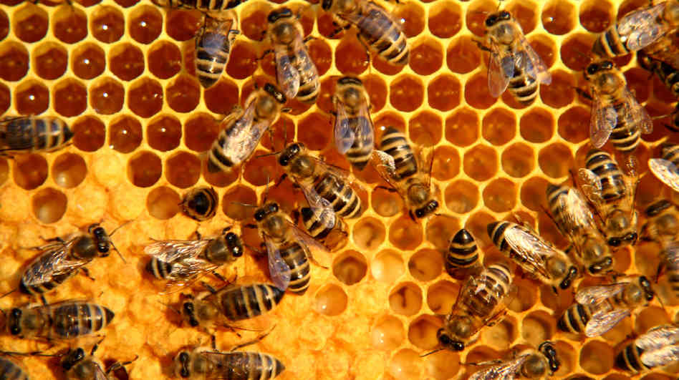

Honeycomb

Water
Of
Life

2 October 2016

W A T E R O F L I F E

Independent Christian Church—Conservative Lutheran Doctrine

Worship Service: 9:30 a.m. Bible Study: 10:45 a.m.

Larry Cooper, Pastor E-Mail address:
111 N. Ridge Road lcooper@wateroflife.cc
Coon Valley, WI 54623 Web Site:
Phone: (608) 452-2105 www.wateroflife.cc

* * * * * * * * * * * * * * * * * * * * * * * * * * *

Sermon Text: Song Of Solomon 4:11

Honey & Milk

* * * * * * * * * * * * * * * * * * * * * * * * * * *

Song of Solomon 4:11 Thy lips, O my spouse, drop as the honeycomb: honey and milk are under thy tongue; and the smell of thy garments is like the smell of Lebanon.

As we read this verse, the words “honey” and “milk” immediately jump out at us. These words are not foreign to us. We can’t help but think of the description of the Promised Land recorded by the Holy Spirit for us in Deuteronomy 11:7-12:

Deuteronomy 11:7 But your eyes have seen all the great acts of the LORD which he did.
8 Therefore shall ye keep all the commandments which I command you this day, that ye may be strong, and go in and possess the land, whither ye go to possess it;
9 And that ye may prolong your days in the land, which the LORD sware unto your fathers to give unto them and to their seed, a land that floweth with milk and honey.
10 For the land, whither thou goest in to possess it, is not as the land of Egypt, from whence ye came out, where thou sowedst thy seed, and wateredst it with thy foot, as a garden of herbs:
11 But the land, whither ye go to possess it, is a land of hills and valleys, and drinketh water of the rain of heaven:
12 A land which the LORD thy God careth for: the eyes of the LORD thy God are always upon it, from the beginning of the year even unto the end of the year.



And for honeycomb, Luke 24:41-43 comes to mind: 41 And while they yet believed not for joy, and wondered, he said unto them, Have ye here any meat?
42 And they gave him a piece of a broiled fish, and of an honeycomb.
43 And he took it, and did eat before them.

